 | North America Standard Operating Procedure | Document # | SOP-013
 | North America Standard Operating Procedure | Prepared By | Stephanie Simmons
 | North America Standard Operating Procedure | Version # | 2.1
 | North America Standard Operating Procedure | Implementation Date | April 19, 2024
 | North America Standard Operating Procedure | Approved By | -
SOP Owner | Service Operations | Last Revision Date | January 29, 2025
SOP Name | Same-Day Replacement (Theft & Loss)

Purpose
This document outlines the process for promptly fulfilling approved Same-Day claims for devices affected by theft or loss. The process aims to provide a replacement device to the customer within the same business day, subject to certain conditions, to minimize disruption and ensure a speedy resolution for the customer.

Responsibilities
The primary responsibility of this process is to provide clear instructions to Servify team members involved in the handling of Same-Day Replacement claims.

Role | Responsibilities
Claims Team | - Order creation on Best Buy website.  - Update Best Buy order details in 360.  - Order monitoring to move statuses forward in 360.  - Get replacement IMEIs from Best Buy (once daily).  - IMEI allocation and completing claims.
Service Delivery | - Best Buy order monitoring.  - Canceling orders when necessary.  - Canceling claims when necessary.
System | - Replacement matrix  - In-store availability check (< 50 miles of customer’s zip code)  - Knox Guard activities (lock, wipe, enroll, unlock)

Process Map
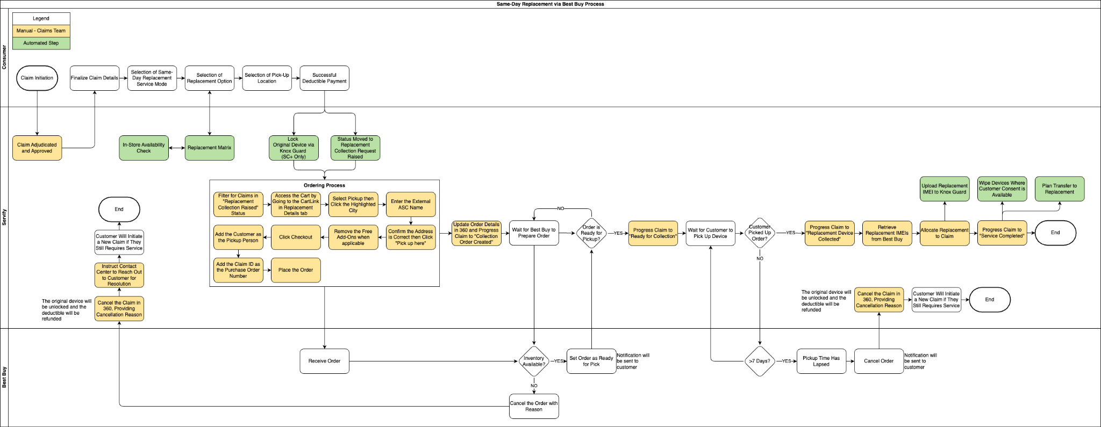

Process

RAISING THE CLAIM

Service Mode Selection
- After adjudication and approval, the customer will choose a service mode. This SOP explains the process for the Same-Day service.
- Note: Same-Day service is only available for phones and tablets.

Replacement Matrix and Pickup Location Selection
- The system will utilize the replacement matrix to allocate a replacement for the customer.
- This replacement device will be cross-checked for in-store availability at the nearest Best Buy locations. If the replacement is available within a 50-mile radius of the customer's location, the customer will be shown a list of stores where the device can be picked up.
- If the replacement is unavailable, the system will check for the next allocation per the priority of the replacement matrix. The replacement types the system will check for are as follows:
  - Exact Match - the replacement device has the same specifications as the customer’s defective device, i.e., same model, color, storage, and carrier.
  - Like to Like - the replacement device has the same model, color, and carrier as the customer's original device but may have the same or higher storage capacity.
  - Alternate - the replacement device will have the same model and carrier as the customer's original device. However, the color will be different, and the storage capacity will either be the same or higher. The customer will be presented with multiple options to choose from.
  - Upgrade - the replacement device will be an upgraded model compared to the customer’s original device.
- If no replacement option is available, the customer will be asked to proceed with an AE without Defective (Next-day) replacement.
- After the customer confirms their pickup location, they will be prompted to pay the required deductible.

Payment Collection
- The customer will pay their deductible via a secure payment form. If the deductible charge fails, it can be attempted again.

Replacement Collection Request Raised
- After the deductible payment is successfully made, the claim status will progress to "Replacement Collection Request Raised".
- Customers who enrolled with Knox Guard prior to filing a claim will have their device locked via API. If the customer was registered but not enrolled, the device will be set to auto-lock upon enrollment.
- Customers who consented to data wiping will have their device wiped via API after it is locked.

BEST BUY ORDER CREATION
Claims Team
- Same-day replacement orders must be entered into the Best Buy website within 15 minutes of claim authorization (slack channel notification). Place orders for any claims in the "Replacement Collection Request Raised" status.
- Access the claim in 360 and access the customer’s cart by going to the “CartLink” provided in the Replacement Details tab.
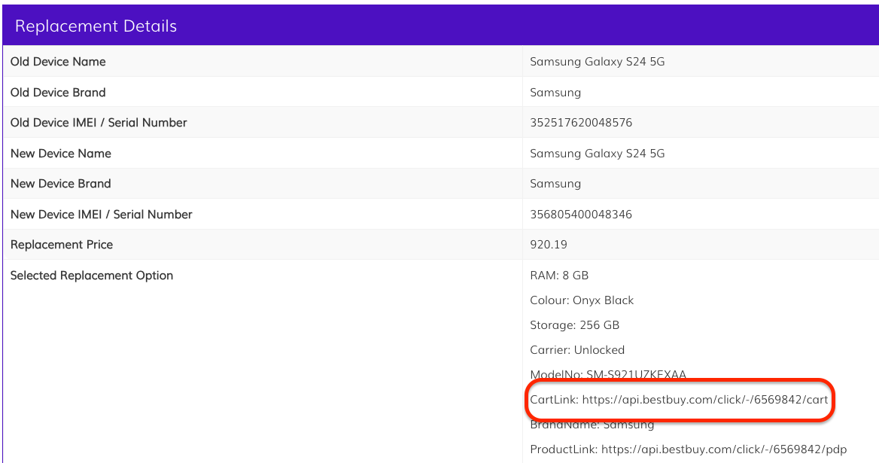
- Ensure “Pickup” is selected, then click the auto-populated city (in the below example, the auto-populated city is Dadeland to update the pickup location.)
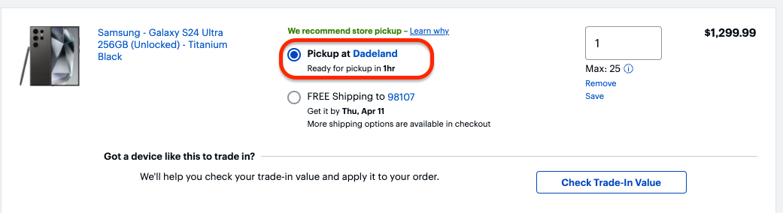
- Locate the chosen pickup location in the Request Details subtab of the claim in 360. Enter the External ASC Name into the “Zip or City, State” field, then click “Go”.
- Confirm that the address in the claim details (External ASC Address) matches the location address displayed by Best Buy. Once confirmed, click “Pick up here”.
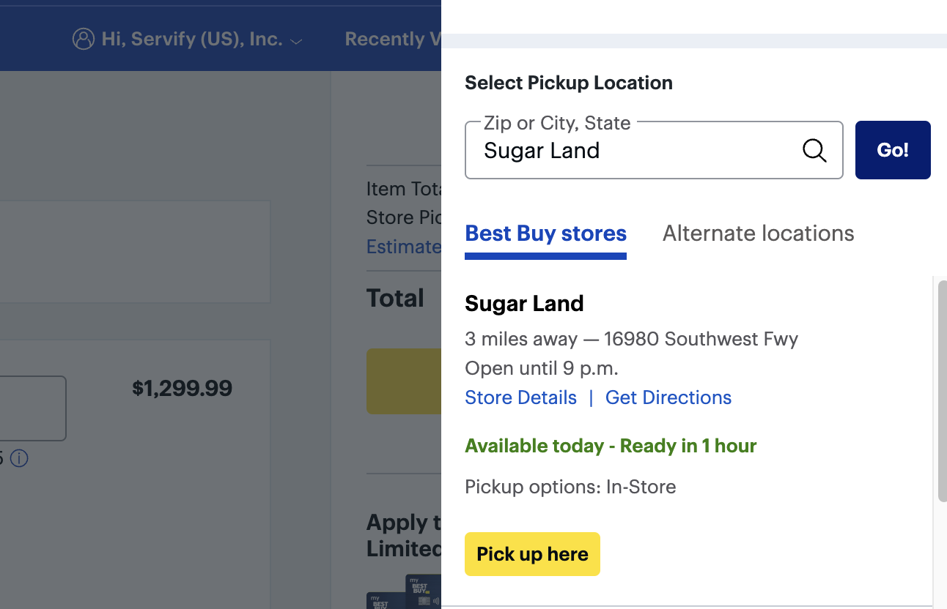
- Remove the free add-ons listed under the “Included Free” section, if there’s anything listed.
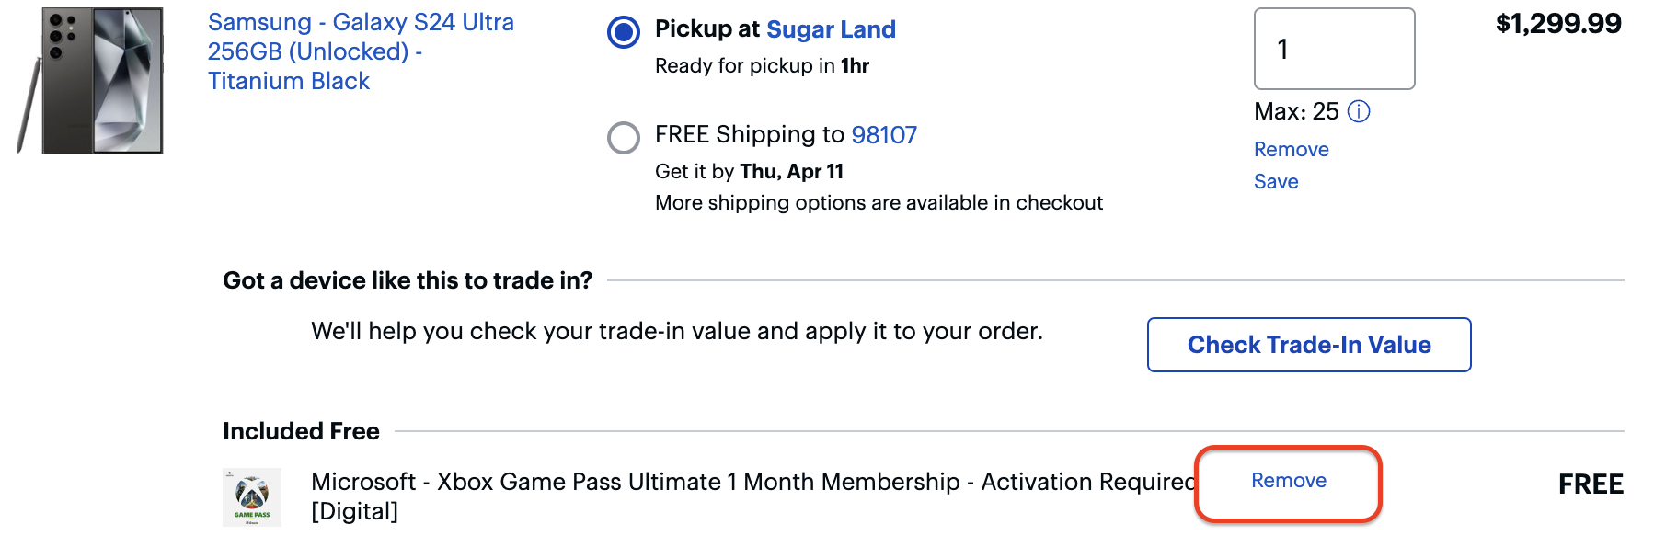
- After removing the add-ons, click “Checkout”.
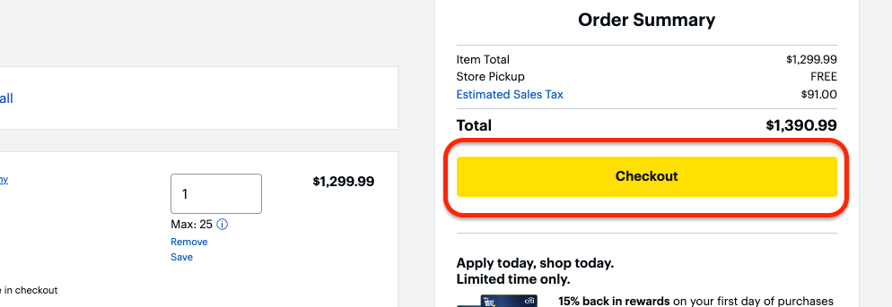
- Click “Add a new pickup person”. The pickup person will be the customer.
- Enter the customer’s Name, Phone Number, and Email Address into the corresponding fields, then click “Apply”. Leave the checkbox empty.
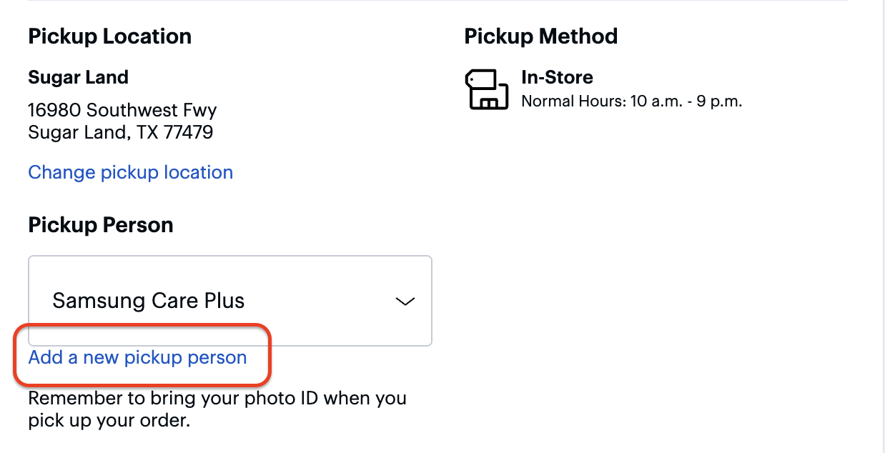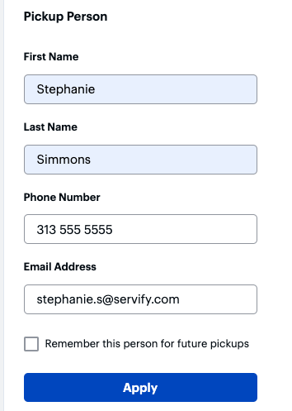
- The Payment Information details will be auto-populated. Enter the 360 Claim ID as the Purchase Order Number.
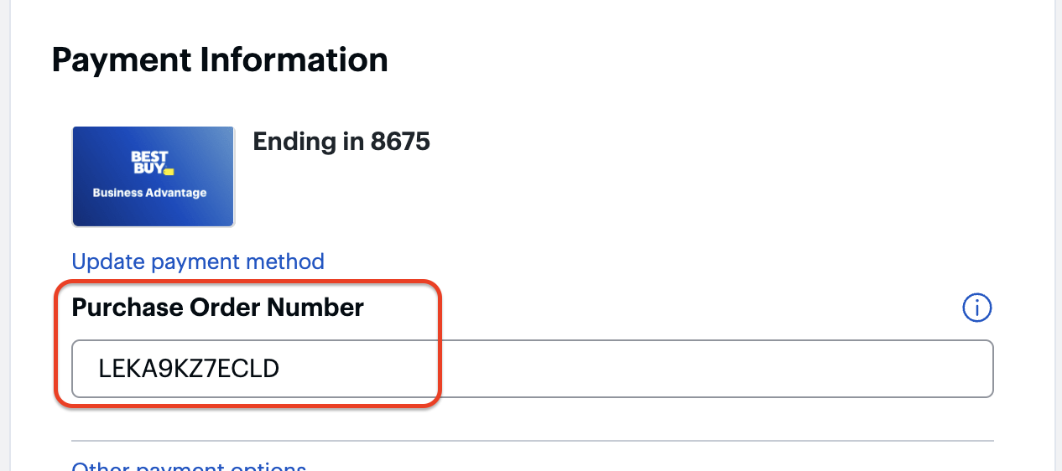
- In the "Contact Information" section, retain the existing number and leave the box unchecked. Click “Place Your Order”.
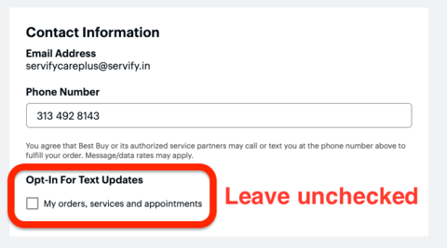
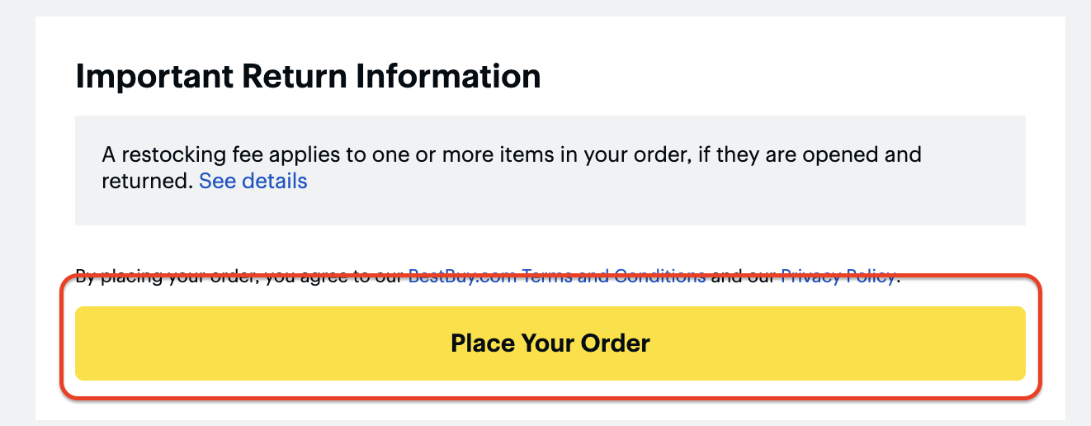
- Capture the Best Buy Order Number from the confirmation page. The order number can also be found in the confirmation email that gets sent to servifycareplus@servify.in.
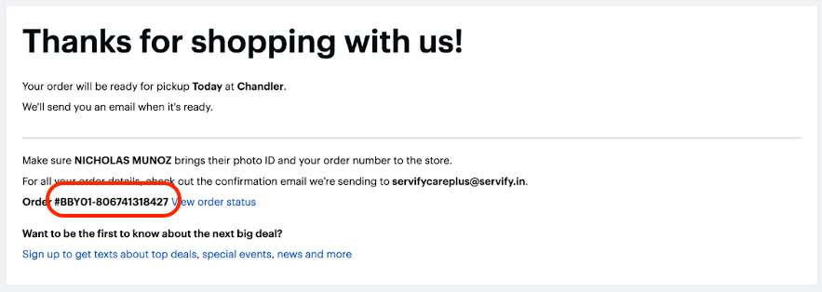

Entering Best Buy Order Details into 360
Claims Team
- After the replacement order has been created with Best Buy, the claim must be updated with the order details in 360.
- Navigate to the claim and click Update Order Details.
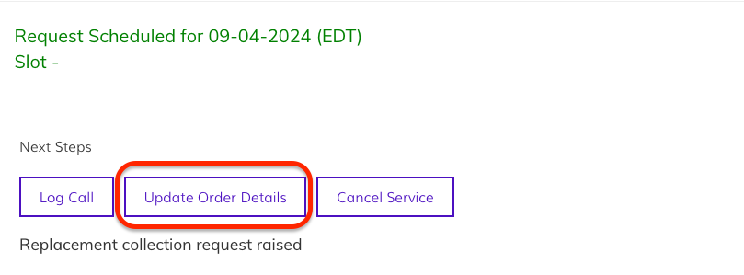
- Enter the Best Buy order number in the Order ID field. Ensure the auto-populated Replacement Model No is correct. Click “Save”. The status will update to “Collection Order Created”..
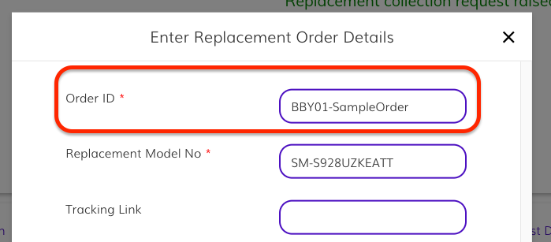

UPDATING BEST BUY PICKUP DETAILS IN 360

Ready for Collection
Claims Team
- When the order is ready for pickup, an email will be sent to servifycareplus@servify.in. The customer will also receive an email and text message from Best Buy letting them know their order is ready for pickup.
- Navigate to the claim in 360 and click "Ready for Collection". Enter the date the replacement is ready for pick up, then click "Submit." The status will update to Ready for Collection.
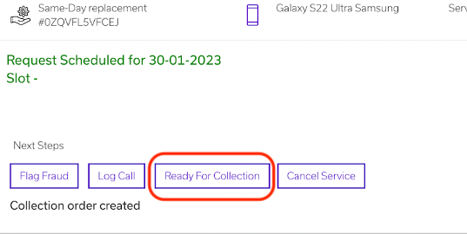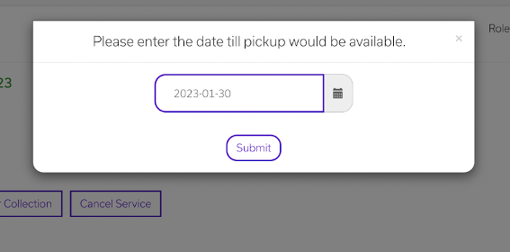

Replacement Device Collected
- After the customer has picked up the replacement from Best Buy, an email will be sent to servifycareplus@servify.in.
  - If the customer doesn’t pick up the replacement in time the order will be canceled.
- Navigate to the claim in 360 and click the "Device Collected" button. Enter the date the customer picked up the device and click "Submit". The status will update to "Replacement Device Collected".
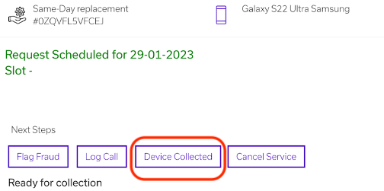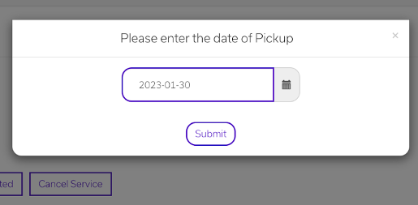

ALLOCATING THE REPLACEMENT AND COMPLETING THE CLAIM

Retrieve Replacement IMEIs from Best Buy
Claims Team
- Filter for claims in the "Replacement Device Collected" status.
- Collect the Best Buy order number(s) from the Request Details subtab. Then, visit the Best Buy website to capture the cost and pick up date information for the orders.
- Send an email to Justin Burwell (Justin.Burwell@bestbuy.com) and copy to get the replacement IMEIs or serial numbers for the claims/orders. Copy Rick Greuel (rick.greuel@bestbuy.com), Apoorv Chandra in the email.
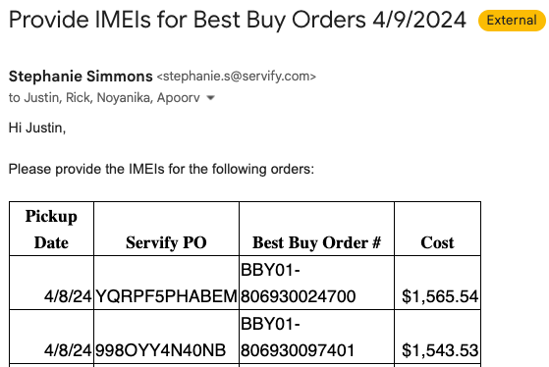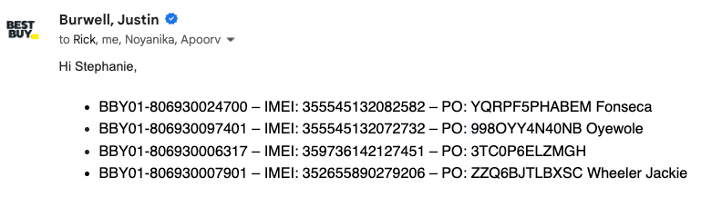

Replacement Allocation
- After receiving the IMEIs from Best Buy, allocate the devices to the respective claims.
  - Navigate to the claim in 360 and click the “Allocate Device” button.
  - Enter the “IMEI” and “Replacement Price”. The status will update to “Replacement Allocated”.
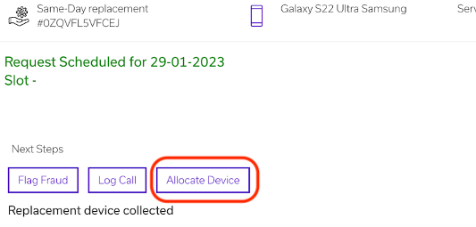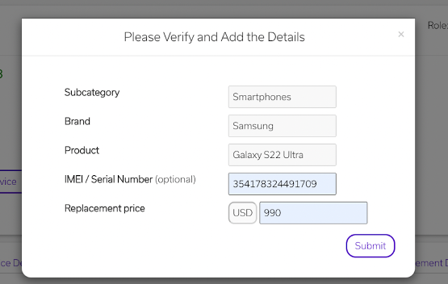

Automated Action
- Once the claim reaches "Replacement Allocated" status, the replacement IMEI will be uploaded to Knox Guard via the Enroll API.

Service Completion
Claims Team
- Click "Complete Service". The claim status will update to "Service Completed," and the plan will transfer to the replacement device.
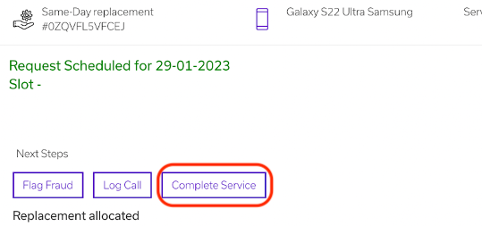
Automated Action
- Once the claim reaches "Service Completed" status, customer data will be erased from their original devices through the Wipe API if they consented to its removal.

Exceptions

CUSTOMER DOESN’T PICK UP THE REPLACEMENT WITHIN THE GIVEN TIME FRAME
Claims Team
- The customer must pick up their replacement from Best Buy within one week; otherwise, the order will be cancelled. Best Buy will send a notification to servifycareplus@servify.in upon cancellation.
- Cancel the claim in 360. The deductible amount will be refunded automatically.

CUSTOMER CANCELS CLAIM BUT BEST BUY ORDER REMAINS OPEN
Service Delivery
- Log Into Best Buy’s Portal
  - Access the Servify Care Plus Best Buy account and log in.
- Locate the Order
  - Search for the order in the Best Buy portal.
  - Click See Details to view order information.
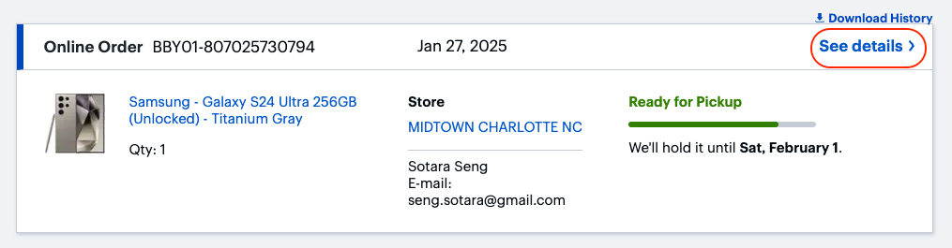
- Initiate Cancellation
  - Click Cancel & Support Options.
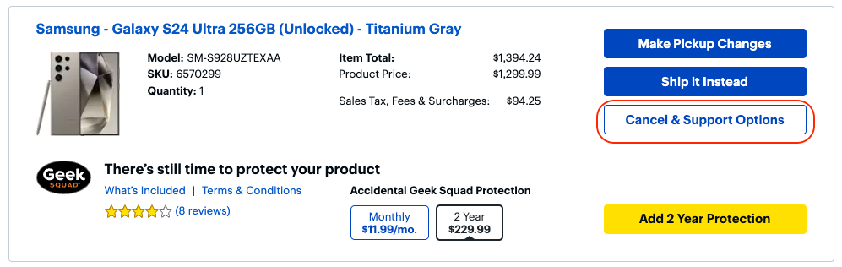
  - From the Order Issue Dropdown, select: "I don’t want this item anymore."
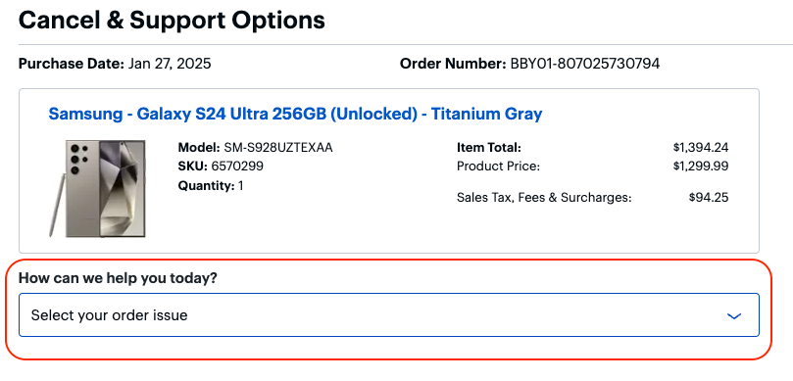
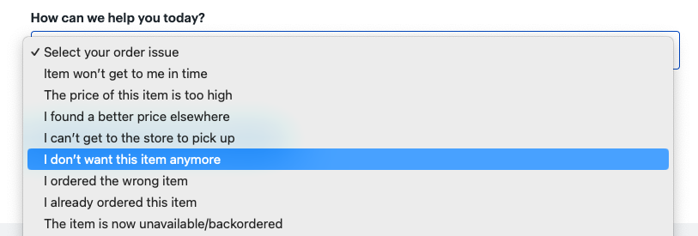
  - Click Continue with Cancellation.
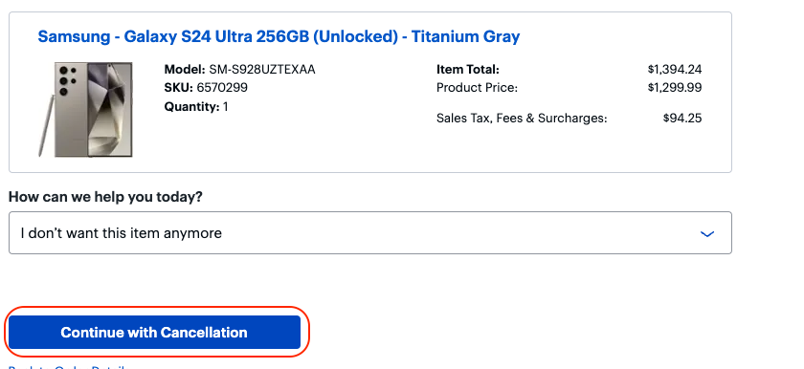
- Click Cancel Item.
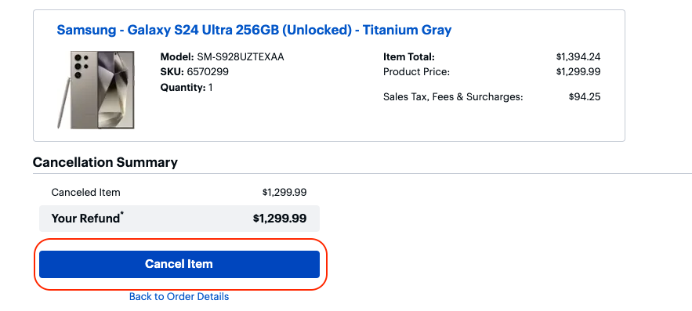
- Verify Cancellation
  - You’ll be presented with a confirmation page stating that the order has been updated.
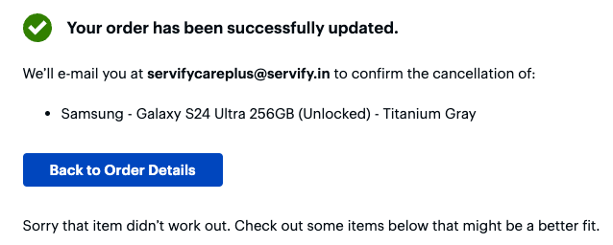
  - Ensure the order status reflects the cancellation.
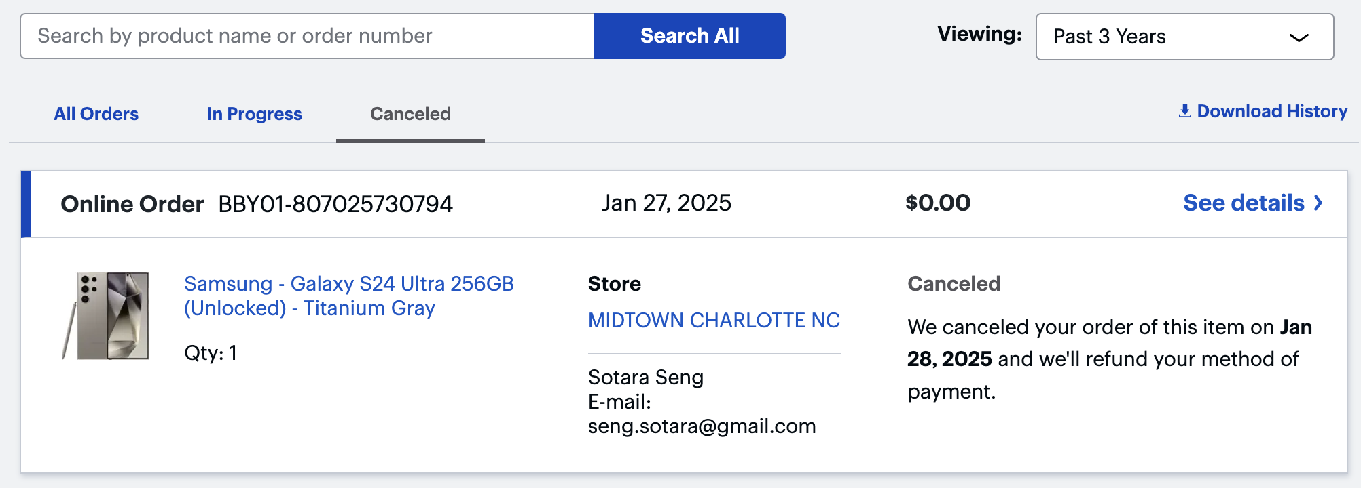

Related Processes
Customer Finds Lost Device

Version History
Version | Approved By | Revision Date | Description of Change |  | Author
1.05 |  | Sep-21-23 | Final Revision of Archived Document |  | S Simmons
1.3 |  | Apr-10-24 | Second Draft Completed |  | S Simmons
2.0 |  | Apr-17-24 | Issued |  | S Simmons
2.1 |  | Jan-29-25 | Added Best Buy order cancellation steps |  | S Simmons

